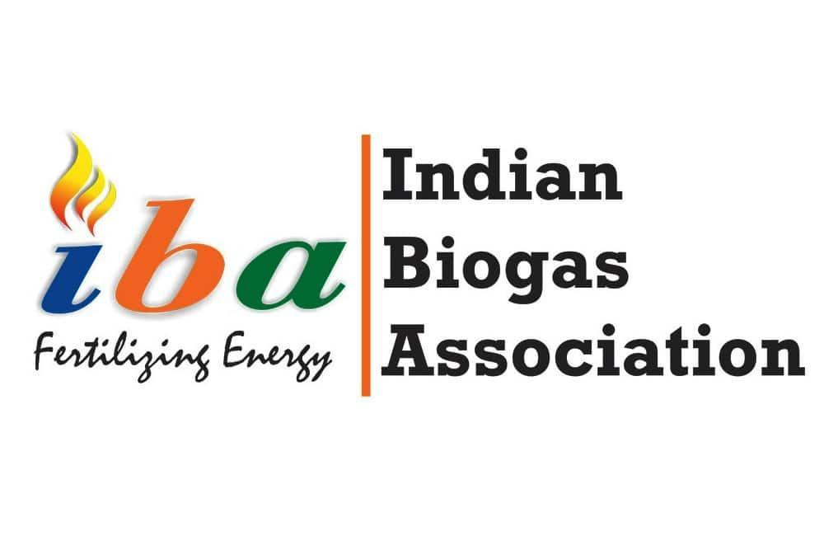

COVERAGE REPORT FOR THE MONTH OF JULY 2023

CONTENT
S.No. | PUBLICATION | STORY | READERSHIP | DATE
 | The Economic Times | MDA scheme to cut 96 lakh tons chemical fertilizer imports, reap benefits of Rs 11,000 cr: IBA | 132,785,220 | July 16, 2023
 | Business Standard | MDA scheme to cut 9.6mn tons chemical fertiliser imports, says IBA | 6,991,696 | July 16, 2023
 | The Morning Context | What’s stopping India from achieving its biogas ambitions? | 136,785,220 | July 13, 2023
 | Zee Business | MDA scheme to cut 96 lakh tonnes chemical fertiliser imports; to reap benefits of Rs 11,000 cr: Indian Biogas Association | 3,961,95 | July 16, 2023
 | The Times of India | Five immediate impacts of boosting the biogas sector | 3,84,470 | July 13, 2023
 | The Print | एमडीए योजना से उर्वरक आयात में होगी 96 लाख टन की कटौती, बचेंगे 11,000 करोड़ रुपये: आईबीए | 3,413,280 | July 16, 2023
 | Live Hindustan | उर्वरक आयात में होगी 96 लाख टन की कटौती | 6,996,759 | July 16, 2023
 | IBC 24 | एमडीए योजना से उर्वरक आयात में होगी 96 लाख टन की कटौती, बचेंगे 11,000 करोड़ रुपये: आईबीए | 4,18,920 | July 16, 2023
 | News Drum | MDA scheme to cut 96 lakh tons chemical fertilizer imports, reap benefits of Rs 11,000 cr: IBA | 1,82,930 | July 16, 2023
 | Zee Business (Hindi) | MDA योजना से बढ़ेगा Organic Fertilizer का उप्तादन, आयात में होगी 96 लाख टन की कटौती, जानिए पूरी डीटेल | 3,961,95 | July 16, 2023
 | Iamrenew | India’s biofertilizer scheme to save indias rs 11000 cr from chemical fertilizer imports says iba report | 1,63,258 | July 16, 2023

