[](https://www.hindustantimes.com/lifestyle/health/ways-to-improve-indoor-air-quality-and-reduce-air-pollution-in-your-home-101655607276273.html)

[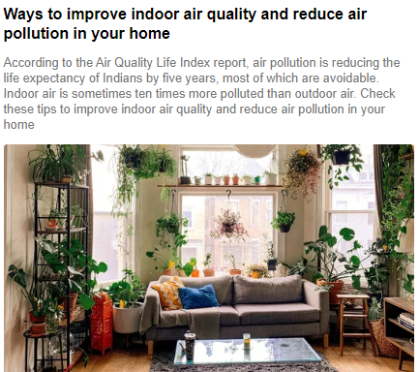](https://www.hindustantimes.com/lifestyle/health/ways-to-improve-indoor-air-quality-and-reduce-air-pollution-in-your-home-101655607276273.html)

[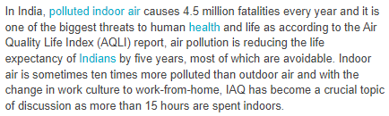](https://www.hindustantimes.com/lifestyle/health/ways-to-improve-indoor-air-quality-and-reduce-air-pollution-in-your-home-101655607276273.html)

[](https://www.freepressjournal.in/world/five-immediate-steps-needed-to-control-environmental-damage)

[](https://www.freepressjournal.in/world/five-immediate-steps-needed-to-control-environmental-damage)

[](https://www.freepressjournal.in/world/five-immediate-steps-needed-to-control-environmental-damage)

[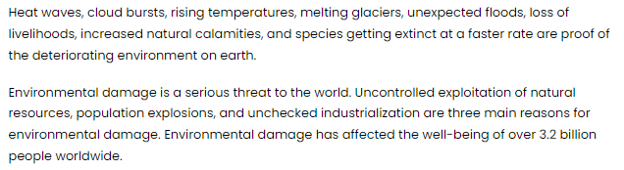](https://www.freepressjournal.in/world/five-immediate-steps-needed-to-control-environmental-damage)

[](https://english.sakshi.com/news/editors-picks/4-organizations-working-towards-environmental-improvement-india-156121)

[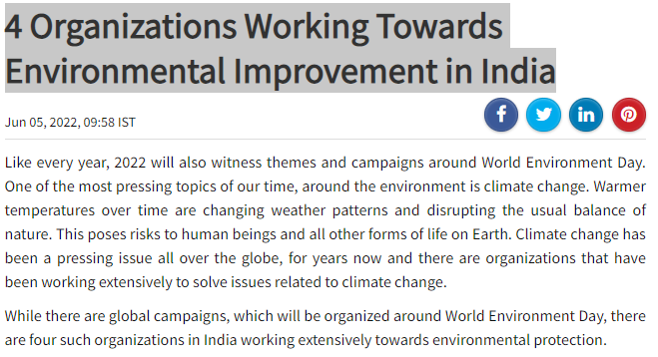](https://english.sakshi.com/news/editors-picks/4-organizations-working-towards-environmental-improvement-india-156121)

[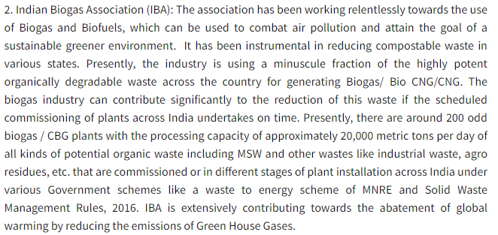](https://english.sakshi.com/news/editors-picks/4-organizations-working-towards-environmental-improvement-india-156121)